Itinerary
July 10th - July 25th

General Notes
- Visit every church possible - church photo complication
- Spend every golden hour outside

Day 1 (July 10th) - Buenos Aires
- Arrive in EZE: 7:35 AM Flight AA931
- Spend day with Fam

Day 2 (July 11th) - Buenos Aires
- Asado con FLIA

Day 3 (July 12th) - Buenos Aires
- Campo

Day 4 (July 13th) - Buenos Aires
- Spend day with fam/prepare and pack

Day 4 (July 14th) - Cafayate
- Depart AEP Airport at 2:40 pm
- Arrive in Salta 4:55 pm
- Get Car
- Drive to Cafayate - 3hrs
- Hostel

Day 5 (July 15th) - Cafayate
- Day in Cafayate
- Horseback Riding
- Garganta del Diablo, El Anfiteatro, El Obelisco, Los Castillos, Quebrada de los Conchas.
- Stop by Molinos for dinner - El Rancho de Manolo
- Quebrada de las Flechas - MUST TAKE PICTURES
- Night Drive to Seclantas - 3hrs

Day 6 (July 16th) - Seclantas/Cachi
- Stay in Seclantas or Cachi for first night
- Caves - Book HERE
- MAY NOT BE ABLE TO DO HIKES DUE TO COLLEIOMAZZA MEETING

Day 7 (July 17th) - Cachi
- Seclantas to Cachi ~ 30 min
- Hotel in Cachi
- Hotel in Cachi
- Ovnipuerto (Alien Landing Site)
- Things to do in Cachi
- Plaza de 9 De Julio
- Iglesia San Jose de Cachi
- Eat Goat Stew
- Llama goulash
- Visit the Cemetery & Mirador Norte

Day 8 (July 18th) - Cachi
- Drive from Cachi to Pumamarca ~ 6.5 hours ON MAPS (probably 8-9, full day)
- Visit Payogasta on the way to get spices?

Day 9 (July 19th) - Purmamarca
- Paseo de los Colorados
- Los Morteros Diner
- Hostel in Tilcara

Day 10 (July 20th) - Purmamarca (Humahuaca)
- Early morning drive to Humahuaca ~ 1 hour
- See Humahuaca - Alltrails
- Lunch in the town? Restaurante Humahuaca
- Not much other food, probably buy in Purmamarca beforehand
- Cerro Negro (12 hours to hike down and back)
- Pena Blanca (3 miles, 1.5 hours roughly)
- Monumento a los Héroes de la Independencia

Day 11 (July 21th) - Purmamarca (Salinas)

Day 12 (July 22th) - Iruya
- Drive to Iruya ~ 3 Hours
- Hostel - Other Options
- Hike Mirador del Cóndor ~ 4 hours
- Hike Mirador De Cruz ~ 15 min for sunset
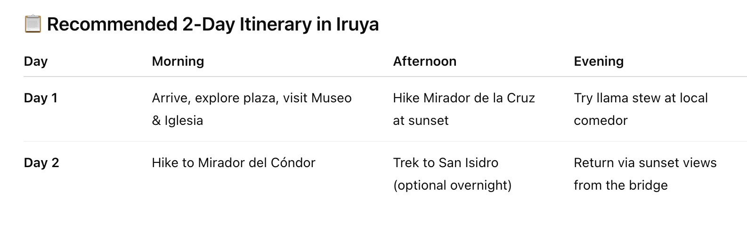

Day 13 (July 23th) - Drive/Salta
- Drive Back from Iruya ~ 6 hours
- Visit Salta for a bit
- Fly back from Salta - Depart 7:10 pm
- Return 9:15 EZE

Day 14 (July 24th)

Day 16 (July 25th)
- Spend day with fam
- Depart EZE - 8:50 pm Flight AA900
Mom Links
El Cortijo Hotel

